**Beirut Blast Impact: NASA Satellite Captures Damage Caused After Beirut Blast from Space**

Beirut Blast Impact: NASA designed satellite-generated synthetic aperture radar to analyse the explosion in Beirut so that new maps could be created. NASA said in a statement that such maps help identify badly affected areas where people need assistance.

Beirut Blast Impact: US space agency NASA has used satellite-generated data to study the bombings on August 4 in the Lebanese capital of Beirut. 163 people were killed in this accident. NASA’s Advanced Rapid Imaging and Analysis team, in collaboration with Earth Observatory in Singapore, has extracted this data

A fierce explosion in Beirut, the capital of Lebanon, killed 135 people and injured about five thousand. The explosion in Beirut was so intense that its echo was heard 160 kilometers away to Cyprus. Beirut Governor Marvan Abod said that about half of the city was damaged by the blast. The city is estimated to have damaged up to $ 15 billion (about one lakh ten thousand crore rupees) due to this massive explosion. Three lakh people have become homeless.

NASA designed satellite-generated synthetic aperture radar to analyze the explosion in Beirut so that new maps could be created. NASA said in a statement that such maps help identify badly affected areas where people need assistance. The map contains processed Copernicus Sentinel data prepared by the European Space Agency. The destruction caused by the explosion has been captured on several satellites. A Skysat spacecraft, which is run by the San Francisco company Planet, has taken detailed photo information of the port of Beirut. Including photos before and after the explosion

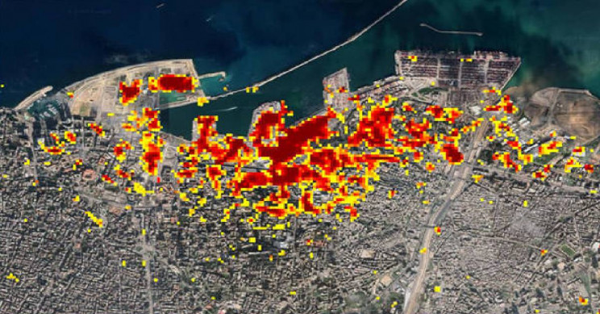

If you look at the map, the dark red pixels in it, which are present around the port of Beirut, show that these areas have been the most affected. Areas that are orange in color are moderately destroyed and yellow areas have relatively less damage. Each color pixel represents an area of 30 meters.

Following the horrific blasts in the Lebanese capital, Beirut, the United Nations is also assessing emergency needs here. The UN says there has been a huge loss of life and property in the blast areas. Explosions affect many people. The UN estimates that 55 primary health centers have been damaged in the horrific blasts in Beirut, with 35 percent of the damage being done. A report of the United Nations Children’s Fund (UNICEF) assesses the educational institutions here. It said that 20 technical schools were damaged.